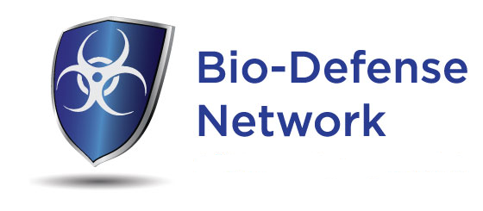

Closed POD Needs Assessment
Potential Closed POD opportunities (rank in order of priority)

______ Recruit Businesses/Organizations to become Closed PODs

______ Prepare Closed POD Workbook tailored to needs of Jackson County Health Department

______ Closed POD Long Term planning session

______ Create or improve a written Closed POD Plan

______ Training sessions for Closed POD Managers/Dispensers

______ Closed POD Exercise planning and execution

______ Develop “Instant POD” concept for use with LTCs and other at risk populations

______ Evaluate operational readiness of existing Closed PODs to activate if needed

Added benefits of any contract for work
Provide Closed POD tracking spreadsheet with assistance to populate spreadsheet
Tailor Closed POD Signup Form

