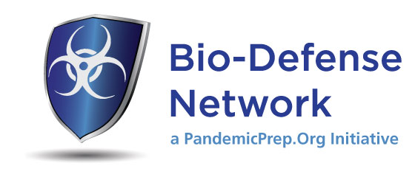
Closed PODs Will Save Lives
The St. Louis County Success Story
At the start of this year, about 270,000 of St. Louis County’s roughly one million residents were covered in Closed POD programs, established at the region’s largest employer; Washington University, 11 acute care hospitals and nearly all the first responder agencies.
But that coverage was woefully inadequate, and meant that in the event of a bio-terror attack, the county would have to activate 15 Open PODs to cover the remaining 730,000 residents. To adequately staff those Open PODs, Department of Health management estimated it would need to rely on 200 county employees per POD, for a total of 3,000 employees, most of whom would need to be trained. That number represents 75 percent of the total county workforce, and was logistically demanding and unrealistic.
Recognizing that expanding its network of Closed PODs would directly increase the probability of saving lives and reduce its staffing and logistical challenges at Open PODs, the St. Louis County Department of Health partnered with PandemicPrep.Org, an area grass-roots organization, to create the Bio-Defense Network.
Using CDC Public Health Emergency Response (PHER) monies, the county invested in a short-term contract with PandemicPrep.Org to staff an intense effort to recruit the area’s largest employers, both corporate and educational. A marketing firm was engaged to create eye-catching printed materials and a new website, and three longtime volunteer members of the organization were hired as full-time recruiters and managers to reach out to potential Closed POD hosts. They relied to some extent on the organization’s existing contacts, but mostly on their motivation, energy and passion for saving lives and serving the community.
As of August 1, 2011, nearly 700,000 residents have been recruited to receive life-saving medications from Closed PODs during a bioterrorism event. That means St. Louis County will be able to halve the number of Open PODs required, from fifteen to six, greatly easing its logistical requirements and allowing it to save many more lives.

The effort has been an unqualified success. The Bio-Defense Network enrolled major employers, including 17 businesses, 38 Long Term Care Facilities, 4 universities, 7 public school districts and 5 government entities. A sampling is below:
Monsanto | 5,000 employees; 20,000 courses
Enterprise Holdings | 4,000 employees; 16,000 courses
University of Missouri - St.  Louis | 4,100 employees and 13,000 local students and their families; totaling 68,400 courses
St. Louis Realtors Association | 6,500 members, 26,000 courses
World Wide Technology | 600 employees; 2,400 courses
Express Scripts | 4,500 employees; 18,000 courses
Savvis Communications | 800 employees; 3,200 courses
Centene Corp. | 700 employees, plus 700 additional building tenants; 5,600 courses

Quickly dispensing medications from the Strategic National Stockpile to those exposed to a bio-terror attack will save countless lives. An excellent way of accomplishing that is to build an expansive network of Closed PODs, which represent an essential outsourcing of distribution to businesses and other organizations.
Recognizing that, the Department of Homeland Security and the Centers for Disease Control and Prevention have made increasing the number of residents covered by Closed Points of Dispensing a priority. It is one criterion evaluated in the CDC’s annual Local Technical Assistance Review of jurisdictions’ readiness to receive Strategic National Stockpile assets.
By replicating the strategy of the Bio-Defense Network, public health departments in other metropolitan areas could dramatically expand the number of residents who would quickly receive antibiotic medications in the wake of a bio-terrorism attack. Service levels will be improved, expenses will be lowered and lives will be saved.
Some employers have approached us about making this a nationwide program for their employees. Your community can join the Bio-Defense Network, enjoying similar success as St. Louis County. For more information, please visit the website www.biodefensenetwork.org or send an inquiry to info@pandemicprep.org.

