Protecting Your Organization
in Public Health Emergencies

Closed Point of Dispensing
Planning Template

[Insert Your Organization name and logo]

Table of Contents

APPOINT A PLANNING COMMITTEE | PAGE
DETERMINING YOUR DISPENSING POPULATION | PAGE
ORGANIZE YOUR STAFF | PAGE
IDENTIFY DISPENSING LOCATION | PAGE
COMMUNICATIONS | PAGE
PREPARING TO RECEIVE AND DISPENSE MEDICATON | PAGE
SECURITY CONSIDERATIONS | PAGE
DISPENSING PROCEDURES | PAGE
APPENDICES | PAGE

- Appoint a Planning Committee

- Collaborative Planning - Establishing a Closed POD for your organization will involve many people from various departments/agencies within and possibly outside of your organization. It is important to have their input during the planning process to obtain their perspective and expertise in establishing operational policies and procedures and to ensure they understand and accept their roles and responsibilities during an emergency that requires establishing a Closed POD.

- Committee Members - Consider the positions below as part of your planning committee. Address the expertise and/or resources they bring to the team to help define their roles and responsibilities. This list is not inclusive. Add/delete positions based on your organization’s structure.
Primary Coordinator/Closed POD Manager
Name: |  |  | Position /Title:
Work Phone: |  |  | Home Phone:
Email: |  |  | Cell/Pager:
What they bring to the planning team:

If the primary is unable to respond, the person(s) below will succeed in management of the POD.
Backup Coordinator
Name: |  |  | Position /Title:
Work Phone: |  |  | Home Phone:
Email: |  |  | Cell/Pager:
What they bring to the planning team:

Security Coordinator
Name: |  |  | Position /Title:
Work Phone: |  |  | Home Phone:
Email: |  |  | Cell/Pager:
What they bring to the planning team:

Logistics Coordinator
Name: |  |  | Position /Title:
Work Phone: |  |  | Home Phone:
Email: |  |  | Cell/Pager:
What they bring to the planning team:

Human Resources
Name: |  |  | Position /Title:
Work Phone: |  |  | Home Phone:
Email: |  |  | Cell/Pager:
What they bring to the planning team:

Business Continuity Manager
Name: |  |  | Position /Title:
Work Phone: |  |  | Home Phone:
Email: |  |  | Cell/Pager:
What they bring to the planning team:

Legal Counsel
Name: |  |  | Position /Title:
Work Phone: |  |  | Home Phone:
Email: |  |  | Cell/Pager:
What they bring to the planning team:

Medical Advisor
Name: |  |  | Position /Title:
Work Phone: |  |  | Home Phone:
Email: |  |  | Cell/Pager:
What they bring to the planning team:

Public Health Liaison
Name: |  |  | Position /Title:
Work Phone: |  |  | Home Phone:
Email: |  |  | Cell/Pager:
What they bring to the planning team:

Other
Name: |  |  | Position /Title:
Work Phone: |  |  | Home Phone:
Email: |  |  | Cell/Pager:
What they bring to the planning team:

- Determining your Dispensing Population:

- Determining the total number of people you expect to service at your Closed POD is a critical step in your planning process. This number will help define the dispensing strategy for your organization by helping determine the size, location and layout of your Closed POD facility; the number of staff volunteers needed to operate the facility; as well as drive the timeline allotted for dispensing medication.

- Total Dispensing Population Includes: {The chart below uses Employees and Clients. Modify the chart to address your designated population – employees, members, faculty, students etc.]
# Employees: |  | # Clients:
# Family Members of Employees: |  | # Family Members  of Clients:
TOTAL (Employees + Family Members): |  | TOTAL (Clients + Family Members
TOTAL DISPENSING POPULATION
Estimates of family members can be calculated by multiplying the number of employees and clients by 4 (average number of persons per household).

- Organize Your Closed POD Staff

- Determine Organizational Structure - Based on the Incident Command System (ICS), your Closed POD is an active part of the Operations Section of the public health response. The ICS structure below identifies all of the potential sections that may be activated to manage and coordinate your Closed POD operations. Determine which roles and functions will be activated and which management staff/volunteers will be assigned to the positions. See Chapter 6 for Job Action Sheets for the specific job functions that will be required at the Closed POD.

NOTE: This diagram is for illustration purposes only.

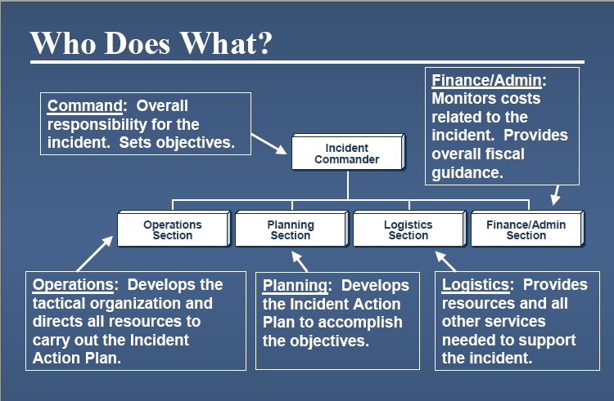

- Determine Staffing Needs – The number of staff volunteers needed to support your Closed POD operations depends on the size of your facility, the floor plan, designated population, desired throughput and time allotted for dispensing operations. (See Chapter 5 for suggested staffing based on your population and the desired throughput.)

List your Closed POD staffing requirements by position
Closed POD Job Position | # Staff Required Per Shift
STAFF REQUIRED PER SHIFT

If you expect to operate more than one shift, multiply the number of staff required by the number of shifts to determine the total number of staff you will need to operate your Closed POD.
- Identify Dispensing Location and design:

- Identify a primary and alternate facility - Based on your organizations operations and the location of your designated population, you may choose to operate more than one Closed POD. For example if your organization operates multiple campuses located throughout the city you may choose to have PODs at each campus. See Chapter 4(f), Closed POD Site Considerations, for further guidance on selecting a dispensing facility location.

Primary Dispensing Facility
Name of Facility
Address
City |  | State |  |  | Zip Code
Phone Number: |  | Fax Number
Alternate Dispensing Facility
Name of Facility
Address
City |  | State |  |  | Zip Code
Phone Number: |  |  | Fax Number
Point of Contact |  |  | Phone Number
Dispensing Facility Campus A (if required)
Name of Facility
Address
City |  | State |  |  | Zip Code
Phone Number: |  |  | Fax Number
Point of Contact |  |  | Phone Number
Dispensing Facility Campus B (if required)
Name of Facility
Address
City |  | State |  |  | Zip Code
Phone Number: |  |  | Fax Number
Point of Contact |  |  | Phone Number

- Facility Design – The design and layout of your Closed POD will impact the efficiency of your Closed POD operations. The visual below is an example of a Closed POD in an employee break room. Design your floor plan to help you achieve the throughput goals developed with your public health liaison. See Chapter 4(l), Sample Floor Plan. {NOTE: Update this section with information relevant to explaining throughput and POD design. Insert your own jurisdiction’s floor plan examples and diagrams as required. Include information on any modeling tools available to help the organization develop their floor plan and throughput goals.}

Sample Facility Floor Plan {Insert your facility floor plan}
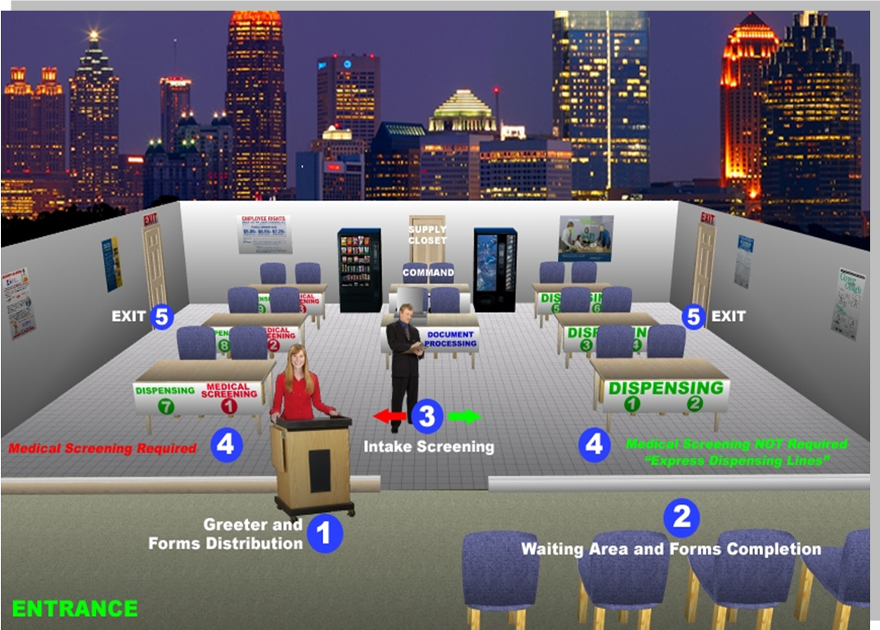

- Communications - It is important to have a robust communications plan to manage your Closed POD operations and to keep your enrollees well informed in the event of an emergency. Your organization most likely has key messages formulated as part of your Continuity of Operations plan. Although not inclusive, consider adding some of the points below specific to Closed POD operations. They are categorized as messages before, during and after the event.

- Before the event, establish an awareness campaign that informs your enrollees of your organization’s partnership with the St. Louis County Department of Health to operate a Closed POD. See Chapter 11 for information letter templates. Consider including the following points in your messages.
- Key roles and responsibilities of enrollees in an emergency that may impact your Closed POD plan.
- Closed POD staff volunteer requirements, duties and training opportunities.
- Define your designated population and describe how medication will be dispensed.
- Explain what information they should be prepared to provide and/or items they should bring to the Closed POD.

Describe how you will communicate with your enrollees before the event and the key messages you will share. List the responsible party for completing this action.
Message (Pre-Event) | Responsible Party

Check all communication methods that you might use to disseminate this information before the event:
Telephone: ____external information line ____call center/phone book
Electronic: ____website posting ____mass email message/fax
In Person: ____meeting/presentation ____visits to clients’ homes
Radio: ____what station(s)
Other: (please specify)

- During the event, consider addressing the following key messages to the appropriate audience.
- Closed POD management staff and staff volunteers -
    - Activation and recall information which includes where and when to report to the Closed POD.
    - Closed POD staff volunteer assigned duties and how to perform those tasks.

- Enrollees:
    - Where and when to go to receive their medications.
    - What information they should have in order to receive their medications.
    - Drug information sheets for the medications, including what they should do if they have a negative reaction to the medication. (This information will be provided by the health department).
    - How to stay informed during the emergency.
    - For employees, consider adding appropriate alternate work schedule instructions.

Describe how you will communicate with your enrollees during the event. List the responsible party for completing this action.

Method of Communication  (During an Event) | Responsible Person

Check all communication methods that you might use to disseminate this information during the event:
Telephone: ____external information line ____call center/phone book
Electronic: ____website posting ____mass email message/fax
In Person: ____meeting/presentation ____visits to clients’ homes
Radio: ____what station(s)
Other: (please specify)

- After the event, consider the following messages for your enrollees
- The importance of taking the entire medicine regimen.
- The outcome of your organization’s dispensing effort.
- How to address questions or concerns.
- How to obtain follow up information.

Describe how you will communicate with your enrollees after the event (and who is responsible):
Method of Communication  (Following Event | Responsible Person
Check all communication methods that you might use to disseminate this information after the event:
Telephone: ____external information line ____call center/phone book
Electronic: ____website posting ____mass email message/fax
In Person: ____meeting/presentation ____visits to clients’ homes
Radio: ____what station(s)
Other: (please specify)

- Preparing to Receive and Dispense Medications

- Closed POD Activation -Closed POD managers will be notified of the necessity of activating their POD by the St. Louis County Department of Health using the county’s Esponder contact system, which will send automated telephone calls, text messages and emails to each Closed POD point of contact.
Once you have been notified that your Closed POD will be activated, you will be given instructions on how and when to receive the medication based on your designated population.
The DOH will make two deliveries to each Closed POD. The first delivery will contain supplies you have ordered and that have been obtained and stored for you by the DOH, and medications for your POD staff and their families. The second delivery will be the medications for your identified population.
There are many considerations to address to ensure your facility is ready for activation. Here are some initial steps to prepare your organization to receive and dispense medications. Modify as needed to fit your organization.
- Establish Recall Procedures - – includes Closed POD management staff and staff volunteer recall procedures.
    - Assign tasks - Use the Job Action sheets in Chapter 6 to assign tasks to staff volunteers upon arrival.
  - Site Set Up – The amount of facility preparation needed to set up the Closed POD depends on the size of your dispensing population and dispensing strategy. Explain how your staff volunteers will receive their tasks to prepare the facility for operations. This includes configuring the facility according to the floor plan sketch, obtaining necessary non-medical supplies, placing appropriate signage throughout the facility (See Chapter 10 for Signage examples) etc.
    - Dispensing Operations – Your public health department will provide assistance with dispensing operations based on the use of the non-medical model, also called the public health model.
    - Just In Time Training - {NOTE - Insert the type of JIT tools your health department will provide to the Closed POD manager so they can initiate during the facility set up operations.

- Receive medications – The amount of medication your Closed POD receives is based on your designated population. The response plans developed by public health state that each person in the affected community will receive one 10-day supply (one bottle containing 20 tablets) of medication. You will receive two shipments of medication. The first shipment will be just enough medicine for your volunteers and their families, so that they may address their most pressing concerns and provide for the safety of their loved ones. Only then will they be able to fully concentrate on assisting the enrollees in your Closed POD. The second shipment will contain the balance of medicine that you will require for your enrollees. Ensure you discuss the necessary security and material handling equipment required so the Closed POD managers can develop their plan. Describe how your organization will receive medication and forms from your public health liaison. Consider the following points -
    - appropriate security measures when medications arrive at your organization
    - appropriate equipment and staff to off load medications and/or move to appropriate storage area or alternate locations (if required).
    - forms reproduction
    - chain of custody procedures for medication
    - completion of the dispensing log
    - collection of the health assessment forms for all enrollees
Describe how your organization will receive medication.

- Internal Distribution of Medication -
If your Closed POD is delivering medications to multiple dispensing sites within your organization, describe your distribution plan including:
- procedures to activate drivers and obtain vehicles
- main storage area to load vehicles
- identification of routes (primary and alternate) used to drop off locations
- maps
- communications plan
- security plan

Vehicle 1 |  | Vehicle 2 |  | Vehicle 3
Type/Make and Model: |  | Type/Make and Model: |  | Type/Make and Model:
License Number: |  | License Number: |  | License Number:
Driver: |  | Driver: |  | Driver:
Contact Number: |  | Contact Number: |  | Contact Number:
Delivery Locations and Routes:
Campus A:
Campus B:

- Storing medications –
  - Your facility may need to provide temporary storage for the supply of medication during dispensing operations. If so, medications should be stored in a secure location (a locked room or locked cabinet where few individuals have access) and kept at controlled room temperature as specified by the medication manufacturer (away from extreme heat or cold).
Describe how and where the medications will be temporarily stored.

- Prepare materials – some forms will be given to each closed POD in advance, such as the Health Assessment Form provided by the State of Missouri and the Dispensing Log created by the St. Louis County Department of Health. Information Sheets on Anthrax and possibly other biological agents may be provided in advance, but will also be updated at the time of an emergency. Closed PODs will receive the same forms that are distributed at public PODs to distribute to your designated population. This involves reproducing enough required materials for your total dispensing population. Forms will include drug information sheets for the medication, medical screening forms, inventory management forms, Frequently Asked Question (FAQ) sheets, and dispensing algorithms.
Describe how your organization will reproduce the required forms. Address any translation requirements.

- Security Considerations
Security is most likely a component of your Continuity of Operations plan. It is also an important component of Closed POD operations. The safety and security of your Closed POD staff and designated population that will come to the facility, the actual facility and the medications being dispensed should be addressed. The following outlines preventive measures to enhance the security of your facility and designated population.

- Physical Security: Take practical steps to prevent unauthorized access to your Closed POD site, facility, and medication:
- Control the flow of traffic arriving and departing from your Closed POD site as well as throughout the Closed POD process.
- Secure unused entrances and exits.
- Pre-identify a secure location within your facility where your medications can be stored until needed.
- Use appropriate signage (See Chapter 10, Signage)

- Personnel Protection: Security measures should be taken to promote the safety of your enrollees and other individuals being served by your Closed POD. Individuals disruptive to the operation of the Closed POD may need to be removed by security and/or law enforcement personnel. Establish a process of emergency communications so Closed POD staff can quickly request assistance from security personnel as needed.

Identify internal communication processes and equipment
Equipment |  | Process
 | Public Address System
 | Hand-held Radios
 | Break room Boards
 | Cell Phones

- Law Enforcement/EMS: Have contact information readily available for your local police department should a security issue arise that requires intervention by local law enforcement. Ensure you have an understanding of your area’s 911 capacity. Consider alternate methods since use of landlines during emergencies may be overwhelmed.

Emergency Contact Information
Law Enforcement
Fire
Insurance

- The Dispensing Process: Step-by Step
- Closed POD Staff Volunteers - Establish procedures to first dispense appropriate quantities of medication to those staff that are assisting with operating the Closed POD. The St. Louis County Department of Health will initially deliver medications for your staff and their families. Those medications must be provided only for your staff volunteers.
- Designated Population – Establish a strategy to dispense to your designated population. Such factors as the Closed POD design, traffic patterns at the facility or your organization’s structure will impact the strategy. For example, upon notification of opening the Closed POD, do these factors support a first come - first come first served strategy or do they better support a phased or tiered approach to dispensing by department or activity. Regardless of the strategy used, it is important to stress that all who come will receive medication in a timely manner and that there is enough medication for everyone within your designated population. Consult your public health liaison for assistance in determining the best strategy for your organization.
- Provided below is a step-by-step process of the dispensing operations most likely to occur at the Closed POD. By establishing procedures to support these steps, your organization is well on their way to developing an efficient dispensing operation to best serve your designated population and your community during a public health emergency.
  - Enrollees complete medical screening form - Prior to receiving medication at PODs, regardless of whether they are open to the public or Closed PODs, each person receiving medication is required to complete a medical screening form. See Chapter 7 for an example medical screening form. Under the Head of Household dispensing method, your employees, members etc. may can complete one screening form for their entire household, but information on each person within the household must be annotated completely on the form. See Chapter 8 for copies of the screening form that all enrollees must complete. You may choose to disseminate the forms on line and have your designated population complete them before arriving at the Closed POD. This could potentially decrease the amount of time it takes them to dispense.
  - Staff reviews medical screening form - These forms are used to screen for possible contraindications to taking the medication.
  - Staff dispenses appropriate medication and drug information sheets - Based on the information provided on the medical screening form and dispensing algorithms, the appropriate medication will be provided for each person listed on the medical screening form. Labels on the Dispensing Log will have each person’s name on the form, which will then be placed on the bottle for each person. The location of the Closed POD may also need to go on the form, depending on State requirements. Each POD will be advised at the time of an emergency of all labeling requirements. Medical screening forms must be completed and maintained by the Closed POD. They must be returned to your public health liaison once the Closed POD has terminated its dispensing operation.
  - Advise enrollee to take the first dose right away.
  - Closed POD Managers may be asked to provide a status update such as the amount of medication dispensed to your public health liaison at various times throughout the dispensing process.
  - Return medical screening forms, inventory forms, and unopened medication bottles to the local public health liaison. This activity will be scheduled following the deactivation of your Closed POD.
Describe how your organization will dispense medications at your Closed POD.

