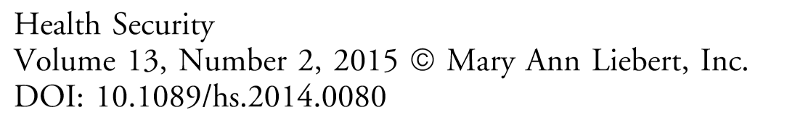

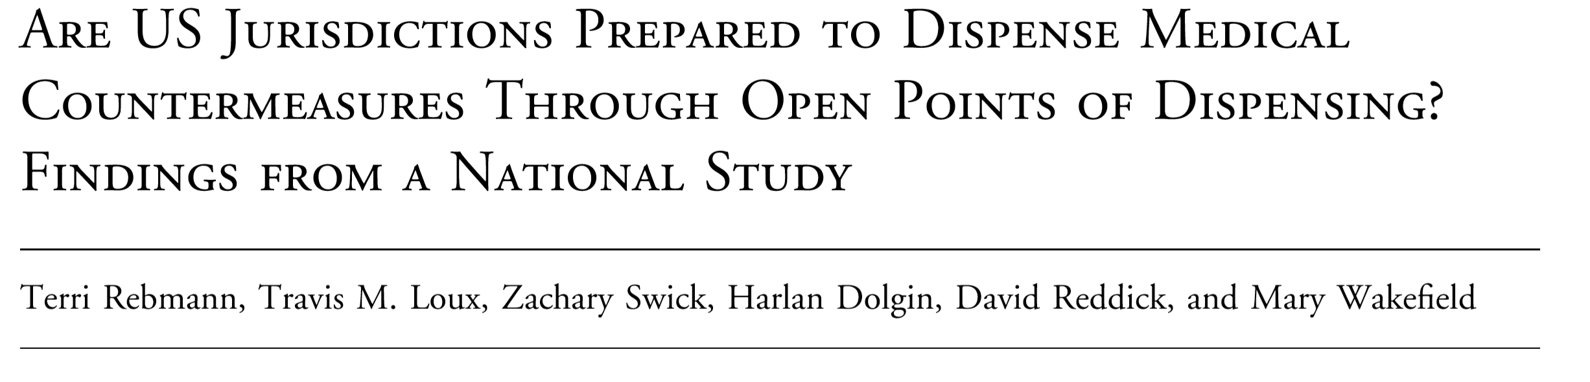
Communities will rely on open points of dispensing (PODs) for mass dispensing of medical countermeasures following a bioterrorism attack or a pandemic. US Cities Readiness Initiative (CRI) open POD preparedness is assessed using the Technical Assistance Review (TAR) but focuses on oral prophylaxis dispensing; mass vaccination readiness is not well measured. Non-CRI preparedness had not been studied. In 2013 an online questionnaire was sent to all 456 CRIs and a random sample of 500 non-CRIs to measure open POD preparedness and exercise participation. Hierarchical linear regression was used to describe factors associated with higher POD preparedness and exercise participation scores. In total, 257 subjects participated, for a 41% response rate. Almost all open PODs have existing written plans and/or a layout for each site (93.4%, n=240, and 87.0%, n=220). Only half (46.7%, n=120) have an alternative dispensing modality in place, and even fewer (42.6%, n=104) report having adequate stafﬁng.* Determinants of open POD preparedness were perceived preparedness, participation in more POD exercises, and more closed POD coverage. Most jurisdictions conducted a full-scale exercise and a staff notiﬁcation drill (83.7%, n=215 for both). Fewer than half (40.5%, n=104) have conducted a vaccination clinic exercise. Determinants of increased POD exercises were perceived preparedness, years of work experience, community type (nontribal), and larger population. Because successful open POD deployment is critical, jurisdictions need to plan for mass vaccination, use of alternative dispensing modalities, and recruitment strategies to increase POD stafﬁng.
CONCLUSION
Findings from this study illustrate open POD planning and exercise gaps in both CRI and non-CRI jurisdictions that are not currently being monitored by the CDC TAR or other performance measures. Examples include a lack of planning and exercises for mass vaccination, insufﬁcient stafﬁng for open PODs in almost half of all jurisdictions, and no planned use of an alternative dispensing modality. These gaps could result in unsuccessful POD deployment if they are not addressed pre-event, leaving community members at risk of increased morbidity and mortality. Jurisdictions need to focus on staff recruitment, planning for mass dispensing of both oral and injectable medical countermeasures, and exercises that assess POD deployment readiness. In addition, it is incumbent on public health leaders to continue exploring alternative dispensing modalities, as they decrease the burden on open PODs and increase community resilience.

The National Academies of Sciences, Engineering, and Medicine,
Published by the National Academies Press, Washington, DC, June 2016
The Nation’s Medical Countermeasure Stockpile: Opportunities to Improve the Efficiency, Effectiveness and Sustainability of the CDC Strategic National Stockpile: Workshop Summary

Anna Nicholson, Scott Wollek, Benjamin Kahn, and Jack Hermann, Board on Health Sciences Policy, Health and Medicine Division

Summary of a Feb. 4-5 Workshop, Washington, D.C.
SNS CHALLENGES
Greg Burel, director of the DSNS, commented that the stockpile has continued to expand its inventory even in the face of shrinking federal budgets. ... He also emphasized the importance of strengthening the dispensing system in the last mile by providing support and guidance to state and local public health officials.
Ali Khan, dean of the College of Public Health, University of Nebraska Medical Center and former director, OPHPR, CDC, offered three observations concerning the SNS based upon his experiences. First, he emphasized that now is the time to revise the SNS mission and statute. … He argued that the SNS needs to be more than a stockpiling program, but a program focusing on the last mile. That is, the SNS should not only deliver MCMs to local public health authorities, but also support local-level dispensation efforts, provide clinical guidance about the use of MCMs, and implement the appropriate systems to monitor treatment compliance during adverse events.
Khan’s (said) the SNS needs to continue to innovate. The Cities Readiness Initiative…and the use of vendor-managed inventory are examples of past successes in this regard, but there is still ample opportunity to increase engagement with industry. Khan’s final observation was that the current SNS model is not sustainable; the SNS cannot continue to buy MCMs for an ever-expanding list of material threats.
Daniel Sosin, deputy director and chief medical officer, OPHPR, CDC, said the “last mile” issue has come to prominence over the past 5 years … as evidenced by the spotlight of attention on state- and local-level public health response capacity for mass dispensing of oral MCMs. Sosin also pointed to the SNS’s critical role in sustaining upstream investment in research, development, and production of MCMs for nonroutine conditions that thus lack enabling market forces: “That commitment to sustaining the investments in producing these medical countermeasures strains and constrains the ability of the Strategic National Stockpile to address the areas of greatest risk.” Over the past 17 years, Sosin reported, fiscal and performance audits of the SNS have demonstrated good fiscal responsibility and stewardship of resources, but this is impeded by the constraints of insufficient resources and the expanding SNS mission.
Sally Phillips, deputy assistant secretary for policy, ASPR, HHS, reflected on the sustainability of the SNS and how investments are being made, noting that sustainability requires taking into consideration not only the amount of resources that go into procuring a stockpile, but also the costs involved in developing, procuring, storing, and deploying the stockpile, which are only a small fraction of the network of the stockpile’s contributions. …Reaching the last mile is a critical concern: “the operational challenges of the stockpile are as intense as the early upfront investments in procuring.”

